

STOCK MARKET ANALYSIS
AND PREDICTION

A PROJECT REPORT
Submitted by
KANAGARAJ P (17BIT008)
BOOPATHY K (17BIT028)
PRASANTH G (17BIT201)

In partial fulfillment for the award of the degree
of
BACHELOR OF TECHNOLOGY
in

INFORMATION TECHNOLOGY

KUMARAGURU COLLEGE OF TECHNOLOGY COIMBATORE-641 049
(An Autonomous Institution Affiliated to Anna University, Chennai)

May 2021


KUMARAGURU COLLEGE OF TECHNOLOGY
COIMBATORE-641 049
(An Autonomous Institution Affiliated to Anna University, Chennai)

BONAFIDE CERTIFICATE

Certified that this project report “Stock market analysis and prediction” is the bonafide work of “Kanagaraj P (17BIT008), Boopathy K (17BIT028), prasanth G (17BIT201)” who carried out the project work under my supervision

SIGNATURE | SIGNATURE
Dr. Alamelu. M, Ph.D., | Dr. THIRUMAL P C, Ph.D.,
HEAD OF THE DEPARTMENT | ASSOCIATE PROFESSOR
Department of Information Technology, | Department of Information Technology,
Kumaraguru College of Technology | Kumaraguru College of Technology
Coimbatore – 641 049 | Coimbatore – 641 049

The candidates university register number 17BIT008,17BIT028,17BIT201 were examined in the Project Viva-Voce Examination held on ……………….

INTERNAL EXAMINAR EXTERNAL EXAMINAR

DECLARATION
We affirm that the project work titled “Stock Market Analysis and prediction” being submitted in partial fulfillment for the award of B.Tech Information Technology is the original work carried out by us. It has not formed the part of any other project work submitted for the award of any degree or diploma, either in this or any other University.

Kanagaraj P (17BIT008)

Boopathy K (17BIT028)

Prasanth G (17BIT201)

I certify that the declaration made above by the candidates is true.

Dr.Alamelu.M Ph.D
Head Of The Department
Department of Information Technology,
Kumaraguru College of Technology,
Coimbatore – 641 049.

ACKNOWLEDGEMENT
We express our profound gratitude to the management of Kumaraguru College of Technology for providing the required infrastructure that enabled us to successfully complete the project.
We extend our gratitude to our Principal, Dr. D. Saravanan, for providing us the necessary facilities to pursue the project.
We would like to acknowledge Dr. M.Alamelu, Professor and Head, Department of Information Technology, for her support and encouragement throughout this project.
We thank our project coordinator Dr.P.C.Thirumal, Associate Professor, Department of Information Technology and guide Dr.P.C.Thirumal, Associate Professor, Department of Information Technology, for their constant and continuous effort, guidance and valuable time.
Our sincere and hearty thanks to staff members of the Department of Information Technology of Kumaraguru College of Technology for their well wishes, timely help and support rendered to us during our project. We are greatly indebted to our family, relatives and friends, without whom life would have not been shaped to this level.
-Kanagaraj
-Boopathy
-Prasanth

TABLE OF CONTENTS

CHAPTER TITLE PAGE NO
- INTRODUCTION 6
  - DESCRIPTION 6
- TECHNOLOGIES AND TOOLS 7
- ALGORITHMS 8
  - SVM (Support Vector Machine for Regression) 8
  - LSTM (Long Short-Term Memory ) 8
  - ARIMA (Auto Regressive Integrated Moving Average) 8
  - RANDOM FOREST 8
  - LINEAR REGRESSION 8
- SYSTEM DESIGN & WORKFLOW 9
- EXPERIMENTS / PROOF OF CONCEPT EVALUATION 10
  - DATASET 10
  - DATA PRE-PROCESSING 10
- RESULTS 11
  - GRAPH 11
  - EVALUATION 12
  - RMSE COMPARISON 13
- DISCUSSIONS 14
  - DECISION MADE 14
  - DIFFICULTIES FACED 14
  - THINGS THAT WORK AND DID’NT 14
WORK WELL
- CONCLUSION 15
- FUTURE SCOPE 16
REFERENCES 16
- APPENDIX 17

CHAPTER-1
INTRODUCTION
1.1 DESCRIPTION
Forecasting of stock market is a way to predict future prices of stocks. It is a long time attractive topic for researcher and investors from its existence. The Stock prices are dynamic day by day, so it is hard to decide what is the best time to buy and sell stocks. Machine Learning provides a wide range of algorithms, which has been reported to be quite effective in predicting the future stock prices.
In this project, we explored different data mining algorithms to forecast stock market prices for NSE stock market. Our goal is to compare various algorithms and evaluate models by comparing prediction accuracy. We examined a few models including Linear regression, ARIMA, LSTM, Random Forest and Support Vector Regression. Based on the accuracy calculated using RMSE of all the models, we predicted prices of different industries.
For forecasting, we used historical data of NSE stock market and applied a few pre-processing methods to make prediction more accurate and relevant.

CHAPTER-2
TECHNOLOGIES & TOOLS
Language and libraries: Python, SciPy, NumPy, Pandas, Sci-Kit Learn, Keras. Keras is required to implement LSTM model. the other libraries are required to process data and implement machine learning algorithms. Pandas made data pre-processing relatively easy.
Tool: GOOGLE colab is convenient to use and is very fast.

CHAPTER-3
ALGORITHMS
3.1 SVM (Support Vector Machine for Regression):
SVM is considered as one of the most important breakthroughs in machine learning field and can be applied in classification and regression. In this project, SVR is considered to solve a regression problem as it avoids difficulties of using linear functions.
3.2 LSTM (Long Short-Term Memory):
It is a recurrent neural network (RNN) architecture that learns about values using intervals. LSTM keeps track of the past values and use those changes to predict future values. In our project we have stock values for each day which can be treated as sequence of values. for its ability to act as memory unit, LSTM can be treated as one of the best algorithms for time-series analysis problems.
For example: Y is present value and X is past value by one day. LSTM will link between X and Y to predict future value.
x | Y
22 | 35
35 | 48
48 | 52

3.3 ARIMA ( Auto Regressive Integrated Moving Average):
ARIMA model works appropriately for modelling time series with trend characteristics, random walk processes, and seasonal and non-seasonal time series . It has simple structure that enables to model our time series dataset characteristics properly.
3.4 Random Forest Algorithm:
Random tree is an ensemble of multiple trees. It has its own way of predicting values. We don’t know whether the data is linear or not. In such cases, Random forest is effective.
3.5 Linear Regression:
It is one of the most used algorithm for regression analysis. This algorithm is implemented to check how it works compared to other algorithms.

CHAPTER-4
SYSTEM DESIGN AND WORKFLOW
The input data is pre-processed by cleaning of data and splitting them into proper sets of training and test. This is in turn is fed to the learning algorithms for the main phase of analysis. Based on the output from the algorithm, the values are predicted and new data has been generated. Generated data are been used for the evaluation of the predicted values to find the accuracy of the algorithms efficiency.
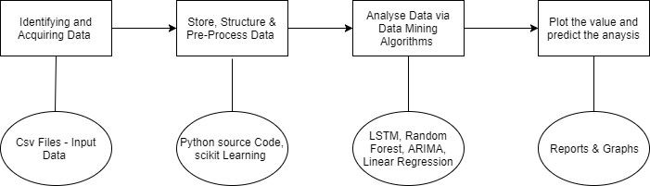

Fig.1: system design
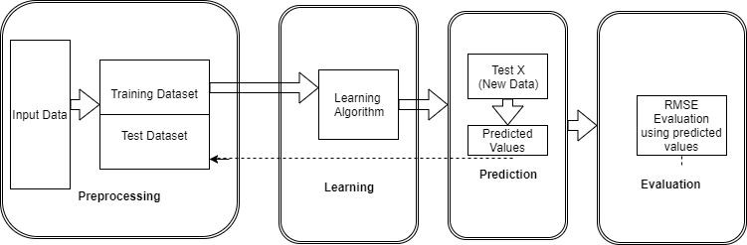

Fig.2: workflow

CHAPTER-5
EXPERIMENTS / PROOF OF CONCEPT EVALUATION
5.1 DATASET
In the project, we chose the National Stock exchange collected from. This dataset includes India stocks and our index covers a diverse set of sectors featuring many Indian companies. Our aim was to focus on making general and unbiased model, which works on every type of scenario irrespective of company or financial sector. It helps to validate our predictive algorithm and provide more accurate stock prediction.
Our dataset includes eight features such as company Index, Date, Time, Open, Close, High, Low values and Volume of trading (prices are in INR). The dataset covers 440 companies every minute since 2015. We took this dataset as it’s size is quite large (~2gb) and it can be used to evaluate several companies using our algorithm. With the primary dataset prepared, we applied pre-processing methods to carry out individual experiments.
5.2 Data pre-processing
Pre-processing refers to the transformations applied to your data before feeding it to the algorithm. Selecting and pre-processing the data are crucial steps in any modelling effort, particularly for generalizing a new predictive model. Our dataset has some limitations such as it contains invalid values, null values and missing records etc. We applied following techniques to pre-process our data to make accurate prediction.
- Data cleaning:
In real world, data tend to be incomplete and inconsistent. Therefore, the purpose of data cleaning is to fill in missing values and correct inconsistencies in the data. Index, Date, time closing prices of NSE dataset are used as input. There were some missing values due to public holidays. We removed null values and invalid indexes. There were few irrelevant columns in the dataset which were not used as input. So we eliminated those columns to reduce the complexity of our prediction model.
- Data Transformation:
As our dataset contains minute-wise stock prices and we needed daily basis prices to fit in our model, so we grouped the data on daily basis prices and took mean of all the rows. Also we applied min-max scaling for a few algorithms to get more accurate prediction.
CHAPTER-6
RESULTS
In this project, we have made a time-series analysis and it doesn’t need n-fold cross validation methodology since it’s sequential data. We split our dataset in train and test data. Top 80 percent of data will be Train data and the remaining will be test.
6.1 Graphs
Below are the few companies with graphs plotted for predicted values(Red) versus actual values (Blue) for different algorithms. We can see that LSTM and Arima performs better compared to random forest and linear regression.
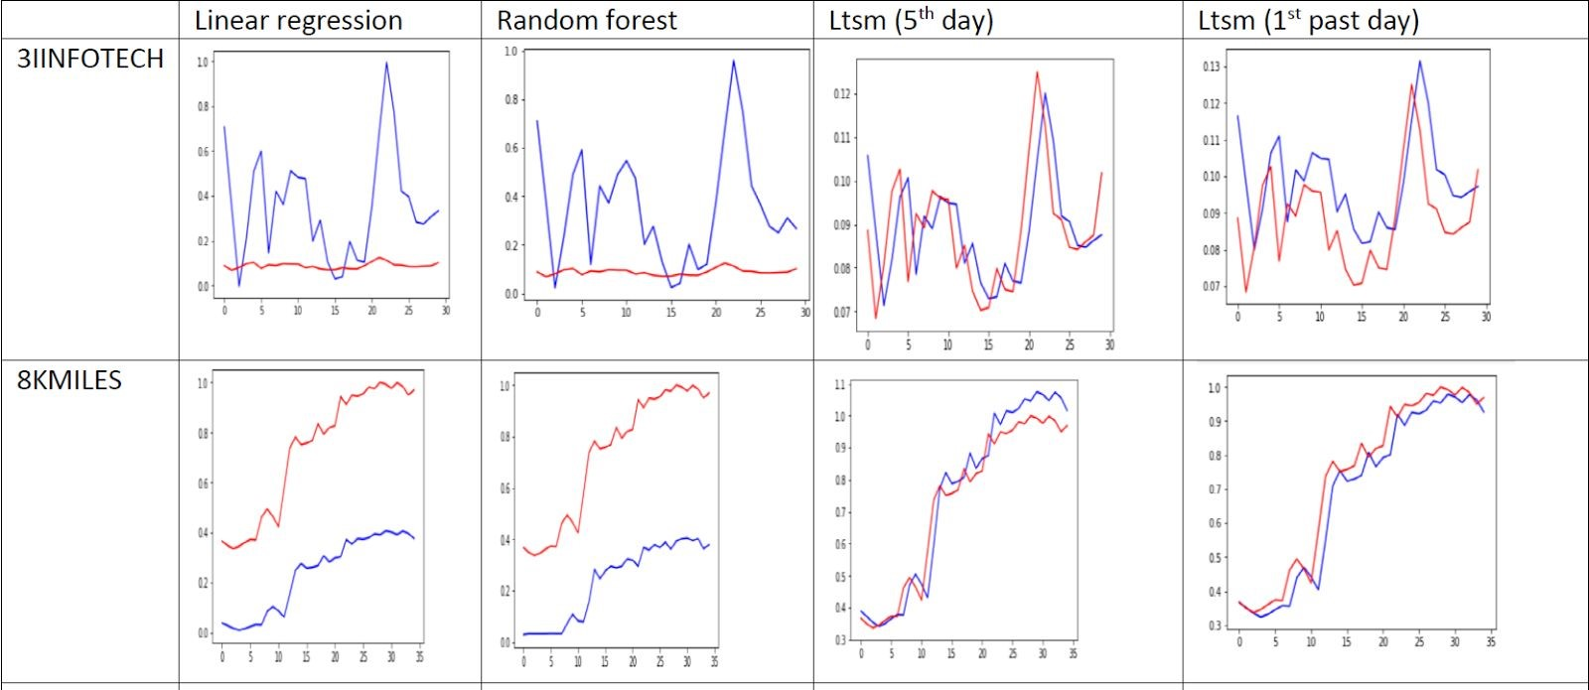
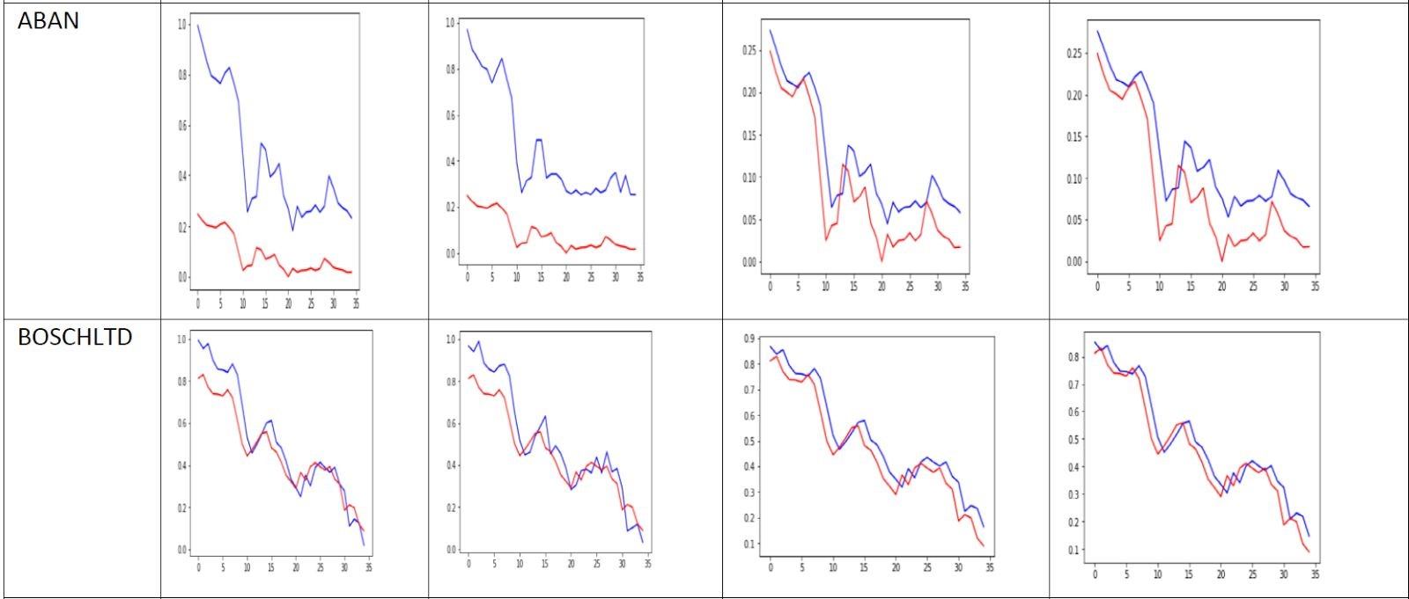
Fig 3: Actual closing price index and its predicted value from LR, RF, LSTM models
Arima model (Monthly basis)
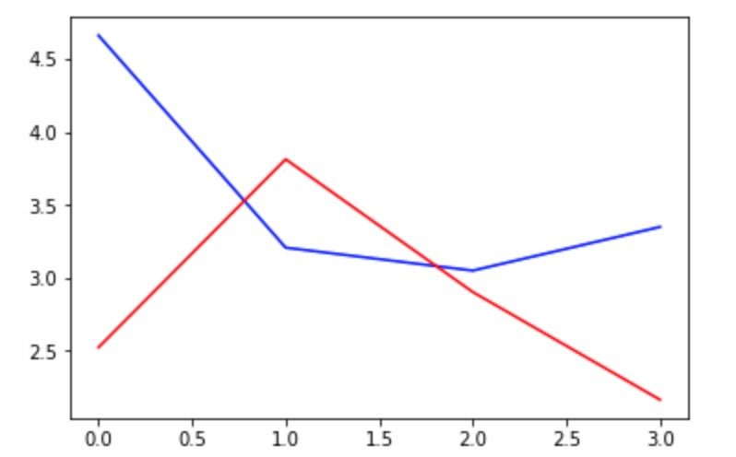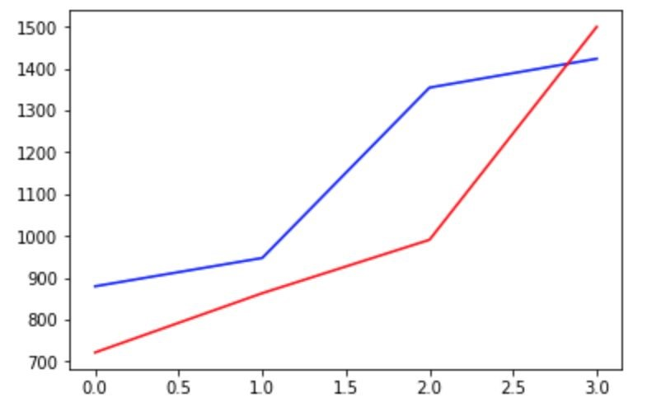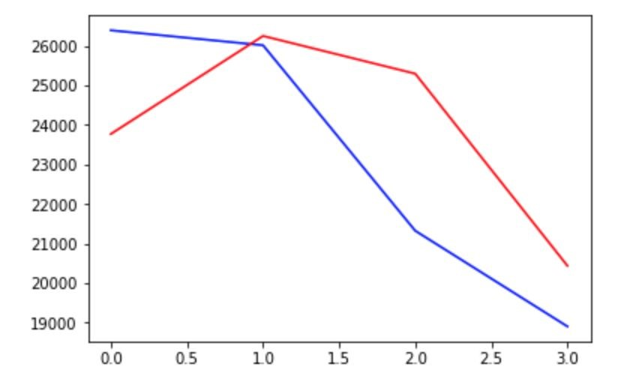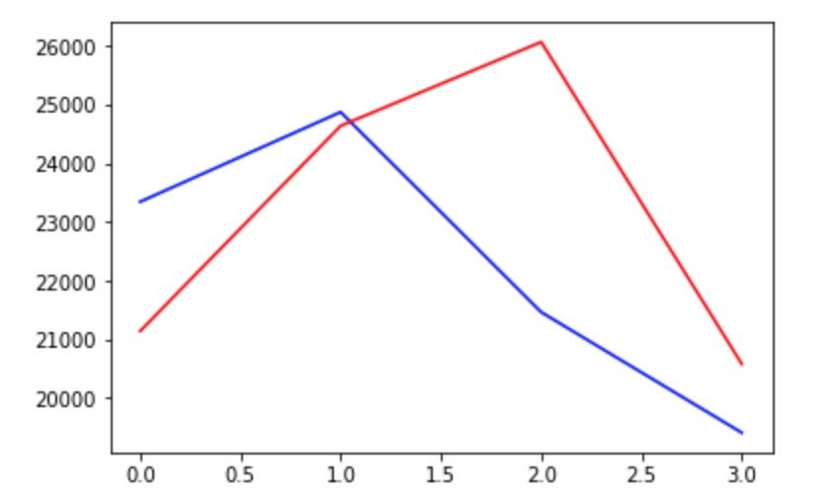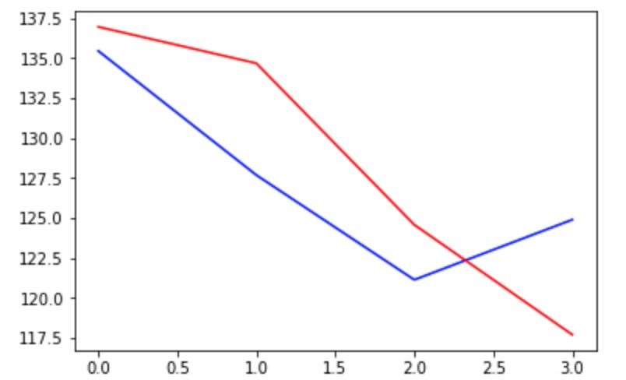

Fig​ ​4:​ ​Graph​ ​Comparison​ ​for​ ​five​ ​companies​ ​(Left​ ​to​ ​right) Infotech,​ ​8kmiles,​ ​Aban,​ ​Bosch​ ​Ltd,​ ​NTPC
6.2 Evaluation
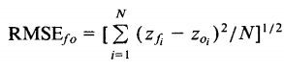
The accuracy of prediction is referred to as “goodness of fit”. In this project, most popular and statistical accuracy measure RMSE is used for comparison of different algorithms on same dataset, which is defined as:
6.3 RMSE Comparison
Model | 3IINFOTECH | 8KMILES | ABAN
Linear​ ​Regression | 0.334 | 0.502 | 0.415
Support​ ​Vector​ ​Regression | NA | NA | NA
LSTM (relating present and past fifth​ ​day​ ​) | 0.011 | 0.064 | 0.043
LSTM (relating present and past day​ ​) | 0.013 | 0.054 | 0.039
Arima | 1.263 | 206.344 | 23.707
Random​ ​Forest | 0.345 | 0.502 | 0.402

CHAPTER-7
DISCUSSION
7.1 Decisions​ ​made
- We decided to make analysis using close values of the stock on a particular day or month and​ ​predict​ ​the closing​ values​ for ​future.
- Decided to work on different data mining algorithms which are Linear regression, Recurrent neural network, Support Vector machines, Random Forest, Arima model with different​ ​approaches.

7.2 ​Difficulties ​ faced​
- Data ​ ​set​ ​is​ ​in​ ​Gb​ ​and​ ​takes​ ​some​ ​time ​ to​ ​ load​ and​ process.
- Preprocessing took some time to extract the values in required format and had difficulty initially on​ understanding​ how​ to​​ forecast.​
- Deciding​ the​ ​ ​features​ ​to​ ​be ​​considered​ ​for​ ​regression​ ​model.

7.3 Things​ ​that​ ​worked​ ​and​ ​didn’t​ ​work​ ​well
- The​ ​models ​ ​that​ ​worked​ ​well ​ ​are​ Long-short​ term Memory​ RNN and​ Arima​ model.​
- SVM​ ​and​ ​linear​ ​regression​ ​didn’t ​give​ ​accurate​ results.
- SVM​ ​took​ ​long ​ time to​ process​ our​ large​ dataset.

CHAPTER-8
CONCLUSION
In the project, We proposed the use of different algorithms to predict the future stock prices of almost twenty companies. Although comparison is shown for only five companies (randomly selected) in the report due to space constraint, the behaviour can be known for any company by using the same code. Long short term memory algorithm worked best in case of forecasting and also we ranged from first to last algorithms for forecasting stock market,
- LSTM
- ARIMA
- RF
- LR & SVR

CHAPTER-9
FUTURE SCOPE
In future, we will extend the project for other effective methods that might result a better performance. Our algorithms can be used to maximize profit of investors but it has to be improved for real time conditions.

REFERENCES
http://markdunne.github.io/public/mark-dunne-stock-market-prediction.pdf
http://citeseerx.ist.p​
​su.edu/viewdoc/download?doi=10.1.1.278.6139&rep=rep1&type=pdf

https://www.kaggle.com/ramamet4/nse-company-stocks

https://machinelearningmastery.com/arima-for-time-series-forecasting-with-python/
https://ec.europa.eu/eurostat/sa-elearning/arima-model

CHAPTER-10
APPENDIX
import numpy as np
import scipy as sp
import pandas as pd
from subprocess import check_output

import time, json
from datetime import date

import time
import math
from keras.models import Sequential
from keras.layers.core import Dense, Dropout, Activation
from keras.layers.recurrent import LSTM
import numpy as np
import pandas as pd
import sklearn.preprocessing as prep
import matplotlib.pylab as plt
%matplotlib inline
from matplotlib.pylab import rcParams
df= pd.read_csv('groupeddf.csv')
df4=df.set_index("Code")
uniqueVals = df["Code"].unique()
grouped_df=pd.DataFrame()
for i in uniqueVals:
df5 = (df4.loc[i,:]).groupby(['Code','Date']).mean()
# store DataFrame in list
grouped_df=grouped_df.append(df5)
grouped_df.reset_index()
del df5
grouped_df
uniqueVals[:10]
def create_dataset(dataset,past=5): # relating 5th day and 1st day
dataX, dataY = [], []
for i in range(len(dataset)-past-1):
j = dataset[i:(i+past), 0]
dataX.append(j)
dataY.append(dataset[i + past, 0])
return np.array(dataX), np.array(dataY)
from sklearn.preprocessing import MinMaxScaler
def testandtrain(prices):
prices = prices.reshape(len(prices), 1)
prices.shape
scaler = MinMaxScaler(feature_range=(0, 1))
prices = scaler.fit_transform(prices)
trainsize = int(len(prices) * 0.80)
testsize = len(prices) - trainsize
train, test = prices[0:trainsize,:], prices[trainsize:len(prices),:]
print(len(train), len(test))
x_train,y_train = create_dataset(train,1)
x_test,y_test = create_dataset(test,1)
x_train = np.reshape(x_train, (x_train.shape[0], 1, x_train.shape[1]))
x_test = np.reshape(x_test, (x_test.shape[0], 1, x_test.shape[1]))

return x_train,y_train, x_test,y_test
def trainingmodel(model, trainX, trainY):
model = Sequential()
model.add(LSTM(20, input_shape=(1,1)))
model.add(Dense(1))
model.compile(loss='mean_squared_error', optimizer='rmsprop')
model.fit(trainX, trainY, epochs=10, batch_size=1, verbose=2)
return model
from sklearn.metrics import mean_squared_error
from sklearn.preprocessing import MinMaxScaler

def predicting(prices, testX,testY,trainX):
scaler = MinMaxScaler(feature_range=(0, 1))
prices = prices.reshape(len(prices), 1)
prices.shape
scaler = MinMaxScaler(feature_range=(0, 1))
prices = scaler.fit_transform(prices)

testPredict = model.predict(testX)

error = math.sqrt(mean_squared_error(testY, testPredict))
print('Test RMSE: %.3f' % error)

plt.plot(testPredict,color="blue")
plt.plot(testY,color='red')

plt.show()
print (" --------end for the company------")
return testPredict

for val in uniqueVals[:10]:
df1=grouped_df.loc[val,:]
df2=df1.reset_index()
prices = df2['Close'].values.astype('float32')
print (val)
#train model
model = Sequential()
trainX, trainY, testX, testY=testandtrain(prices)
model = trainingmodel(model, trainX, trainY)

#predict and plot
predictingY=predicting(prices,testX,testY,trainX)

